RE-PRESENTATIONS
Free online streaming
of selected Athens & Epidaurus Festival performances
As part of the Hellenic Ministry of Culture & Sports initiative
“We Stay at Home with Culture”

Theseum Ensemble – Michail Marmarinos
Insenso
by Dimitris Dimitriadis

Athens Festival 2012
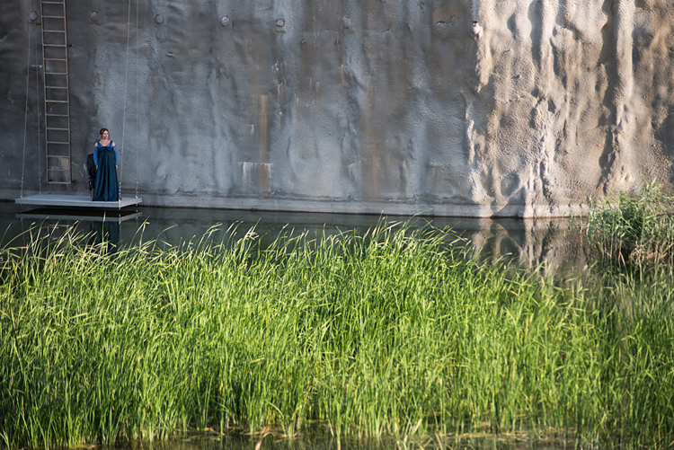
The Athens & Epidaurus Festival continues to offer free streaming of filmed performances and concerts, drawn from its rich archive. Participating in the Hellenic Ministry of Culture initiative “We Stay at Home with Culture”, the Festival shares standout moments from the long history of the institution, staying in touch with audiences, until the time is ripe for everybody to come together and enjoy fresh Festival experiences.
The streaming premiere of Lefteris Voyatzis’ production of Sophocles’ Antigone (Epidaurus Festival 2006 and 2007) met with an enthusiastic response and was watched online at home by over 36,000 viewers. Now, theatre lovers will have the opportunity to watch yet another performance that left its mark on the Festival history: a production of Dimitris Dimitriadis’ Insenso, directed by Michail Marmarinos for Athens Festival 2012; a hugely successful site-specific performance that was repeated in the summer of 2013. Special mention must be made to director and producer Yiannis V. Lapatas for filming this production and transporting viewers to the mystical atmosphere of the live event. We are deeply indebted to him for his contribution.
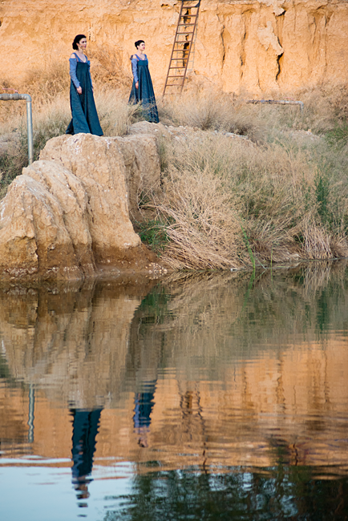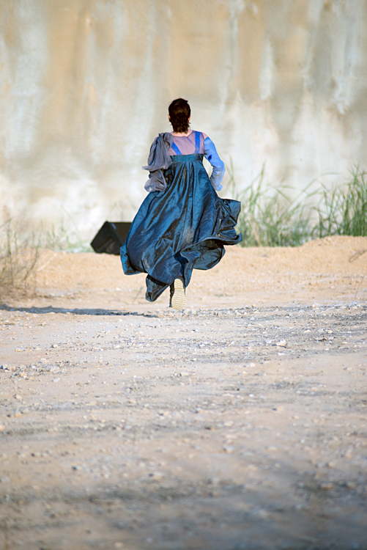

The unexpected scenic landscape in which Insenso unfolded was etched in the memory of all spectators: a lake behind the industrial building of Peiraios 260, the existence of which nobody could have ever suspected; an otherworldly, vast, deserted universe, haunted by the memory of the heroine of the play, Countess Livia Serpieri. The character was ‘shared’ across twenty female bodies – as many as the performers who urged visitors, divided into groups of female and male spectators, to take sides and allow themselves to be carried away into the narrative stream, much like the heroine was swept away by the stream of History. Spectators then proceeded to Hall D of Peiraios 260, where they were confronted with a captivating setting that alluded to the inner landscape of the heroine’s tower, Aldino.
This performance can be described as a long aria about the enduring memory of romantic passion; a stage poem of rare beauty about the endless struggle between love and duty, social class and homeland, but mainly between human existence and time.
*
From the published edition of the text

“A human being is a lot for another human being to take. Nothing more exists for a human being than another human being.* Nothing fills up a human being more than another human being. And the one who gives becomes a god for the one who receives (…)”.

Dimitris Dimitriadis, Insenso
(excerpt from the play)

The play is inspired by Luchino Visconti’s famous film Senso (1954) and is set around the end of the Third Italian War of Independence, in 1866, at a time in which the Venetian resistance against the occupation forces rages on. Countess Livia Serpieri falls in love with Austrian officer Franz Mahler. Driven mad with despair after he leaves her, she turns him in as a deserter. He is immediately arrested and executed. This is a story of double betrayal: first, betrayal of one’s country due to love; then, betrayal of a lover due to the despair of abandonment. The story of a person driven mad with love; a lovelorn person being pushed beyond reason and moderation, beyond acceptable limits: In-senso, the utter defeat of common sense; an overwhelming triumph of the senses.
[...]
Unlike viewers of Visconti’s film, readers of Insenso are not going to actually read about any of the events. The plot is contained in the first six phrases uttered on stage: “I am [...] I turned him in [...] By order [...] I heard the fusillade [...] I screamed [...] I was lost [...] From then to this day [...] I keep thinking about one thing only [...]”: These phrases punctuate the text as if there were the ticking of a clock counting minutes and hours through eternity with the same meticulous, relentless precision. “From then to this day” – time is compact and defined by only one ‘thing’: the heroine’s desire to go back in time and kill her lover; this time, with her bare hands.
Dimitra Kondylaki
(Excerpts from the text “The Utopia of Union”
Indiktos 2007 & Saixpirikon 2013)
*
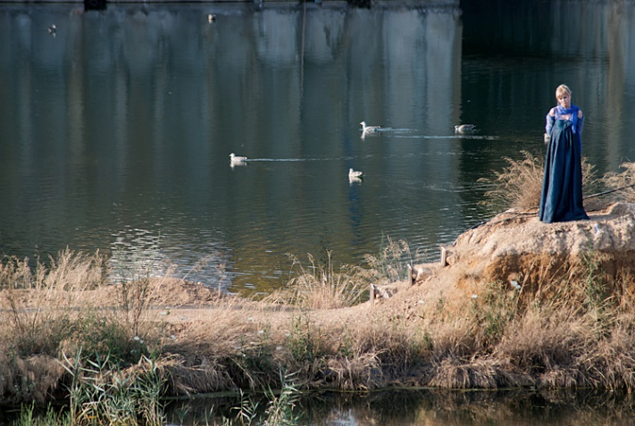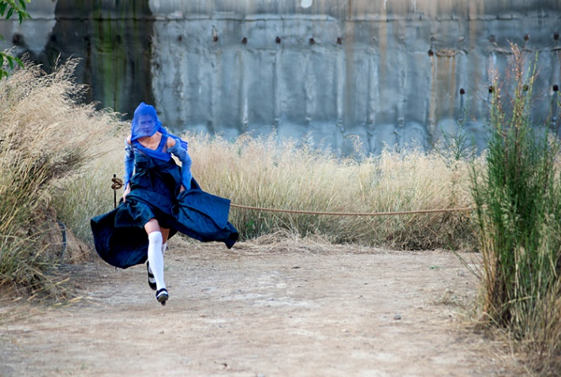

Insenso (Athens Festival 2012)
Credits
Written by Dimitris Dimitriadis • Translated into Italian by Spyros Pervolarakis • Directed by Michail Marmarinos • Musical composition Dimitris Kamarotos • Costume and set design Dora Lelouda • Architectural design and supervision Dimitris Zamenopoulos • Lighting design Giannis Drakoularakos • Assistant director Myrto Pervolaraki • Second assistant director Elena Moudiri-Chasiotou • Assistant to the costume and set designer Spyros Pervolarakis • Sound design STUDIO 19 • Audio stream Costas Bokos • Production manager Rena Andreadaki • Theseum Ensemble director Eleni Petassi
Women Sandra Garuglieri, Nadia Mourouzi, Maria Nafpliotou, Elektra Nikolouzou, Theodora Tzimou, Jenny Drivala and Ioanna Asimakopoulou, Alexandra Aidini, Marilou Vomvolou, Virginia Katsouna, Katerina Kyvetou, Reggina Mandilari, Daphne Manousou, Evi Blesiou, Eleni Petassi, Olga Spyraki, Maria Stavraka, Dora Stylianesi, Sofia Filonos, Anastasia Chatzara • Piano Irene Tiniakou • The Austrian Josef Rüttger
Our warmest thanks go to Zissis Kotionis and Io Carydi, as well as to Rena Fourtouni, Athanasatos Music House and actor Nektarios Papalexiou.
Special thanks to the Foundation of the Hellenic World for kindly providing the Festival with the area where the first part of the performance was held.
Photos: Aris Kamarotos
*
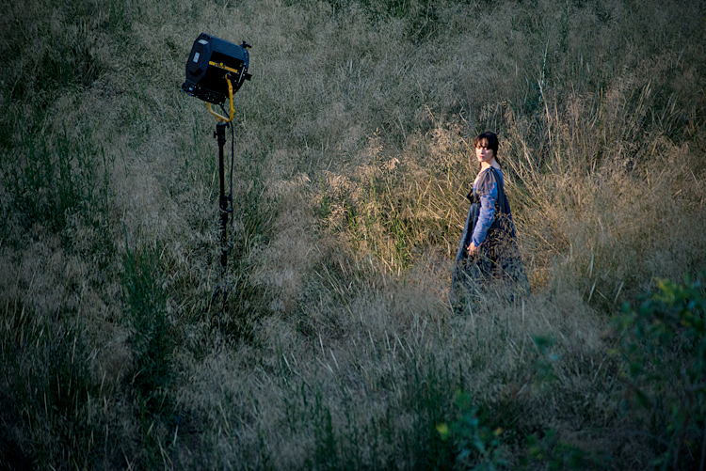
Insenso will be streamed, free of charge, on Saturday, 2 May 2020, through our official YouTube channel: Greek Festival and will be available for streaming for 24 hours.
In the coming weeks, we will continue to offer you free online streaming of performances and concerts that left their mark on the Athens & Epidaurus Festival in recent years, especially those filmed in a format that allows their broadcast. Follow us on the official Festival website and social media where we will keep you posted on things to come.
Online streaming is possible thanks to the support of the Hellenic Ministry of Culture and Sports.
Enjoy!

Disclaimer: Please keep in mind that shows have been filmed
as a documentation of the Festival’s history
and were not intended for public broadcast.
We ask the audience’s understanding for any technical issues.
The performance is presented in Greek only, without subtitles.

Watch the Athens & Epidaurus Festival performances:
Website www.greekfestival.gr
YouTube Greek Festival
Facebook AthensAndEpidaurusFestivalGr
Instagram athensandepidaurusfestival

